Name: Shanne Edralyn N. Erandio Date Submitted: 10/30/25
Course, Year and Section: BSIT2A Subject: Platform Technologies

Lesson 3 – Assessment 3 (Laboratory Activity):
Alison Course Completion + Cloud Service Simulation
Activity Title:
Google Cloud Computing Foundation + Cloud Deployment Simulation

Objective:
To develop foundational knowledge and hands-on familiarity with Google Cloud concepts, architecture, and services by completing the Google Cloud Computing Foundation course and performing a short simulation of deploying or managing cloud resources.
This activity enhances cloud literacy, problem-solving, and documentation skills—essential for IT and software-related roles.

Screenshot Requirements and Placement
- Alison Dashboard showing 100% completion
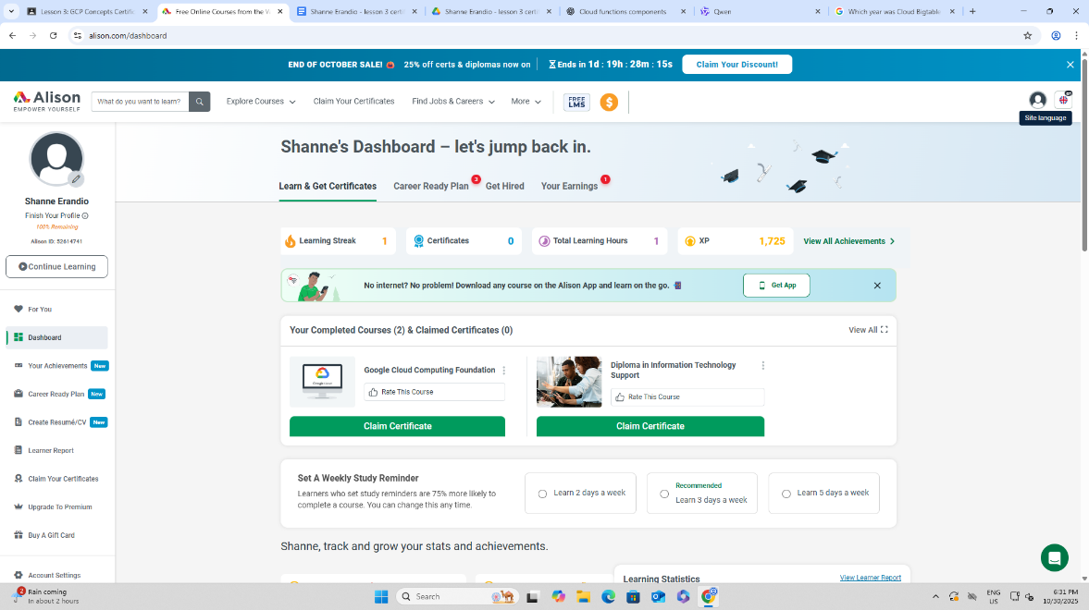

- Assessment Results or Progress Page (with quiz scores
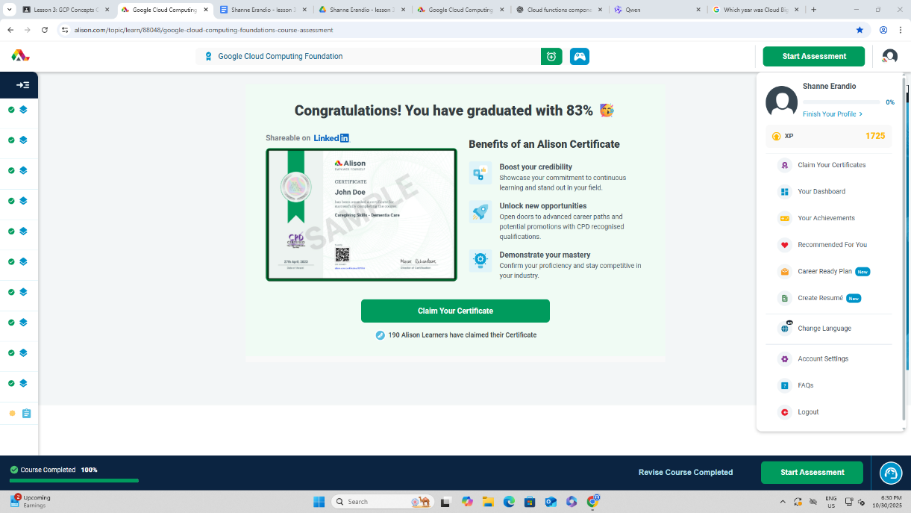

3. Certificate of Completion (PDF or screenshot)

Scenario: Cloud Storage provides a scalable, secure, and highly available solution for storing and sharing data in the cloud. Learning how to properly upload, manage, and share data enhances efficiency, collaboration, and data governance in an organization. The key takeaway from this exercise is understanding the workflow of managing cloud storage resources, including bucket creation, object upload, permissions, and sharing options.
Simulation: Uploading and Sharing Data Using Cloud Storage
Objective: Simulate creating a Cloud Storage bucket, uploading data, and sharing it with specific users.

Step 1: Log in to Google Cloud Console
- Navigate to Google Cloud Console.
- Authenticate using your Google account with appropriate permissions (e.g., Storage Admin role).

Step 2: Create a Cloud Storage Bucket
- In the Navigation Menu, select Storage → Browser.
- Click Create bucket.
- Enter a unique bucket name (e.g., project-data-bucket).
- Select a region or multi-region depending on data residency needs.
- Choose a storage class:
  - Standard for frequently accessed data
  - Nearline/Coldline/Archive for less frequent access
- Configure access control:
  - Uniform bucket-level access (recommended for consistent permission management)
- Click Create.

Step 3: Upload Data to the Bucket
- Open your newly created bucket.
- Click Upload files or Upload folder.
- Select the desired files or folders from your local machine.
- Monitor the upload progress and ensure all files complete successfully.

Step 4: Set Permissions for Sharing
- Inside the bucket, click Permissions → Add.
- Enter the email addresses of the users or groups you want to share with.
- Assign appropriate roles:
  - Storage Object Viewer – read-only access
  - Storage Object Admin – full control over objects
- Click Save.

Step 5: Generate Shareable Links (Optional)
- Select a file in the bucket.
- Click Get link.
- Configure link access:
  - Restricted (only specific users)
  - Public (anyone with the link)
- Copy and distribute the link as needed.

Step 6: Verify Access
- Ask a collaborator to access the bucket or object using the provided link or permissions.
- Ensure proper role-based access and file visibility.
Technical Notes:
- Buckets are the top-level containers for objects in Cloud Storage.
- Objects refer to the individual files stored in buckets.
- Roles and permissions in Cloud IAM control access to buckets and objects.
- Uniform bucket-level access simplifies security by applying the same policies to all objects.
Outcome:
Successfully uploaded data to Cloud Storage and shared it securely with intended collaborators, ensuring proper permissions and access control.
Reflection:
The Google Cloud Computing Foundation course provided a clear and structured introduction to cloud computing fundamentals and Google Cloud’s ecosystem. The most valuable takeaway was understanding the shared responsibility model and how Google Cloud abstracts infrastructure management while empowering users to configure security, networking, and compute resources effectively. I particularly appreciated the modules on Identity and Access Management (IAM) and Virtual Private Cloud (VPC), which clarified how permissions and network isolation work in real-world deployments.
The course demystified core services like Compute Engine, Cloud Storage, and BigQuery by explaining their use cases and integration patterns. One challenge was grasping the nuances of IAM roles versus permissions, but the interactive quizzes helped reinforce the concepts. The billing and cost management section was also eye-opening—it emphasized the importance of setting budget alerts and using committed-use discounts, which are critical for operational efficiency.
This foundational knowledge will significantly benefit my future career in software development. As more applications migrate to the cloud, understanding how to deploy, secure, and monitor resources on platforms like Google Cloud is essential. I now feel more confident designing cloud-native applications and collaborating with DevOps or infrastructure teams. Additionally, this course has motivated me to pursue further certifications like the Associate Cloud Engineer.

Criteria | Excellent (16–20 pts) | Very Good (11–15 pts) | Good (6–10 pts) | Needs Improvement (1–5 pts) | Poor (0 pts) | Score
1. Course Completion | Completed with certificate; all modules finished with high scores | Completed; cert shown with minor issues | Completed but unclear details | Incomplete; missing cert | No attempt
2. Screenshot Documentation | All required screenshots attached, clear and visible | Minor screenshots missing or unclear | Some blurry or missing details | Screenshots cropped or unreadable | None
3. Reflection Quality | Deep insight, thoughtful, and articulate | Clear and relevant with good depth | Basic ideas, surface-level | Very short or vague | None
4. Cloud Simulation | Clear, realistic, and technically accurate | Mostly clear, logical, professional | Limited realism or minor technical errors | Unclear or incorrect flow | Not submitted
5. Timeliness | Submitted on/before deadline | 1–2 days late | 3–5 days late | 6+ days late | Not submitted
Total Score: ___________

